GEMINI HISTORICAL ARTIFACT DESCRIPTION
Team ID : LTVIP2026TMIDS77577
TEAM MEMBERS:
Kudavalli Sujitha
Lakshmi Durga Bhavani Sankar Gunturu
Borra Vikash
Lakshman Seshapu
PROBLEM STATEMENT:
Historical artifacts hold great cultural and educational value, but they often lack clear descriptions especially in digital platforms or museums. This project addresses that problem by providing accurate and precise description of the artifact from image and avoiding the need of manually maintaining details about the artifact. This helps the educators, students, and curators better understand and document the artifacts from all around the world.

REQUIREMENTS:

Functional Requirements:
The interface should allow users do the following tasks:
  - Uploading the image of an artifact (.png, .jpeg,
.jpg).
  - Input the image along with optional prompts by the user.
  - Generate a description of the artifact given by the user.

  - Download the description generated as a text file.

Non-Functional Requirements:
The non-functional requirements include:
  - Providing an accurate description to the user prompt.
  - User should easily be able to access the features of the artifact description through a user-friendly interface along with safety integrated through API keys and environment variables.

PROJECT OVERVIEW:
The web application is built using Streamlit which allows the users to upload an image of the historical artifact to receive an AI generated description. It uses Gemini 1.5 Flash model from Google’s Generative AI API’s; it supports both texts and images.

PROJECT STRUCTURE:
The project folder includes the following files:

requirements.txt

The file contains the Python libraries and packages needed to be installed for the project
- README
Provides an overview of the project.

app.py
This Python folder contains all the main code which helps make this generative model work

.env
Helps in storing sensitive and vulnerable information such as API keys.

CODE:
- Requirements.txt
Streamlit
google-generativeai Pillow
python-dotenv

- app.py
from dotenv import load_dotenv import streamlit as st
import os
import google.generativeai as genai from PIL import Image

# --- Configuration ---load_dotenv()
api_key = os.getenv("GEMINI_API_KEY") genai.configure(api_key=api_key)

# --- Utility Functions ---
def input_image_setup(uploaded_file): if uploaded_file is not None:
bytes_data = uploaded_file.getvalue()

return [{"mime_type": uploaded_file.type, "data": bytes_data}] else:
raise FileNotFoundError("No file uploaded")

def get_gemini_response(input_text, image_data, prompt): full_prompt = f"{prompt}\n\nUser Instruction: {input_text}" model = genai.GenerativeModel("gemini-1.5-flash")
response = model.generate_content([full_prompt, image_data[0]]) return response.text

# --- Streamlit Page Settings ---st.set_page_config(
page_title="🏺 Gemini historical Artifact Description App", page_icon="🏺",
layout="centered",
)

# --- Custom CSS Styling ---st.markdown("""
<style>
.stApp {
background-color: #ecf0f3;
font-family: 'Verdana', sans-serif; color: #222222;
}

.title {
font-family: 'Georgia', serif; font-size: 36px;
font-weight: 700; color: black;
text-align: center; margin-top: 0.5rem; margin-bottom: 0.2rem;
}

section[data-testid="stSidebar"] {
background: linear-gradient(to bottom, #2c3e50, #34495e); color: #ffffff;
}

section[data-testid="stSidebar"] h1, section[data-testid="stSidebar"] h2, section[data-testid="stSidebar"] h3, section[data-testid="stSidebar"] h4, section[data-testid="stSidebar"] h5, section[data-testid="stSidebar"] h6, section[data-testid="stSidebar"] label, section[data-testid="stSidebar"] span {
color: #ffffff !important; font-weight: bold;
}

main[data-testid="stAppViewContainer"] { background-color: #ecf0f3;
}

main[data-testid="stAppViewContainer"] > div:first-child { padding: 0 !important;
margin: 0 !important;
}

.stButton button {
background-color: #4B47C3; color: white;
border-radius: 8px; font-weight: bold; padding: 0.5em 1.4em;
transition: background-color 0.3s ease;
}

.stButton button:hover { background-color: #3934a1;
}

.stTextInput input { background-color: #ffffff; border: 1px solid #ffffff; border-radius: 6px; padding: 0.5em;
color: #000000;
}

.stTextArea textarea { background-color: #ffffff; border: 1px solid #ffffff; border-radius: 6px; padding: 0.5em;
color: #000000;
}

.stMarkdown {
background-color: white; padding: 1.2rem;
border-radius: 12px;
box-shadow: 0 2px 10px rgba(0, 0, 0, 0.05); margin-top: 1rem;
}

.stDownloadButton button { background-color: #6E6E6E; color: white;
border-radius: 6px;
}

.stDownloadButton button:hover { background-color: #4f4f4f;
}

.css-1d391kg, .css-1dp5vir {
background-color: #ffffff !important; border-radius: 12px;
padding: 1rem !important;
box-shadow: 0 2px 10px rgba(0, 0, 0, 0.06);
}

.css-qrbaxs, .css-1v3fvcr { color: #4B47C3 !important; font-weight: 600 !important;
}
</style>
""", unsafe_allow_html=True)

# --- Header ---
st.markdown('<div class="title"> Gemini historical Artifact Description App
</div>', unsafe_allow_html=True)

# --- Sidebar Input Section ---with st.sidebar:
st.header("🏺 Upload Inputs")
uploaded_file = st.file_uploader("Upload Artifact Image", type=["jpg", "jpeg", "png"])
input_text = st.text_area("🏺 Add Context or Custom Prompt (optional)", placeholder="Describe the context, location, or your question...")
submit = st.button("🏺 Generate Description")

# --- Display Uploaded Image ---if uploaded_file:
st.image(uploaded_file, caption="🏺 Uploaded Artifact", use_container_width=True)

# --- Predefined System Prompt ---system_prompt = """
You are a historian. Please describe the historical artifact in the image and provide detailed information, including its name, origin, time period, material, cultural significance, and any other relevant facts.
"""

# --- Output Area ---if submit:
try:
with st.spinner("🏺 Analyzing artifact and generating insights..."): image_data = input_image_setup(uploaded_file)
response = get_gemini_response(input_text, image_data, system_prompt)

# ✅ Soft Pastel Blue Full-Width Container Box st.markdown("""
<div style='
width: 100%;
background-color: #d8f0ff; padding: 1rem 1.5rem; border-radius: 12px; border: 1px solid #b9e6fa; color: #114a63;
font-family: Verdana, sans-serif; font-weight: 500;
text-align: center;
box-sizing: border-box; margin: 1.5rem auto;
box-shadow: 0 2px 8px rgba(0,0,0,0.05);
'>
✅ Description generated successfully!
</div>
""", unsafe_allow_html=True)

st.markdown("### 🏺 AI-Generated Artifact Description") st.markdown(response)

st.download_button(
label="🏺 Download Description", data=response, file_name="artifact_description.txt", mime="text/plain"
)
except Exception as e: st.error(f"⚠ Error: {str(e)}")

# --- Footer ---
st.markdown("---") st.markdown(
"<p style='text-align: center;'>Built using Google Gemini 1.5 Flash · Streamlit UI ·</p>",
unsafe_allow_html=True
)

CODE OVERVIEW:
- The necessary libraries and packages are present in the requirements.txt

- The .env file store the API key and it securely loaded and setup for the project.
- The input_image_setup() function prepares the uploaded image so it can be sent to the API.
- The get_gemini_response() function accepts the user input , sends them to the API and returns the generated description.
- Streamlit allows the interface to accept user input along with prompt and view the description generated in the main area of the page.
- CSS is used to style the website to give it a more user-friendly interface.
- The error is displayed if the user does not upload any image while trying to generate a description.

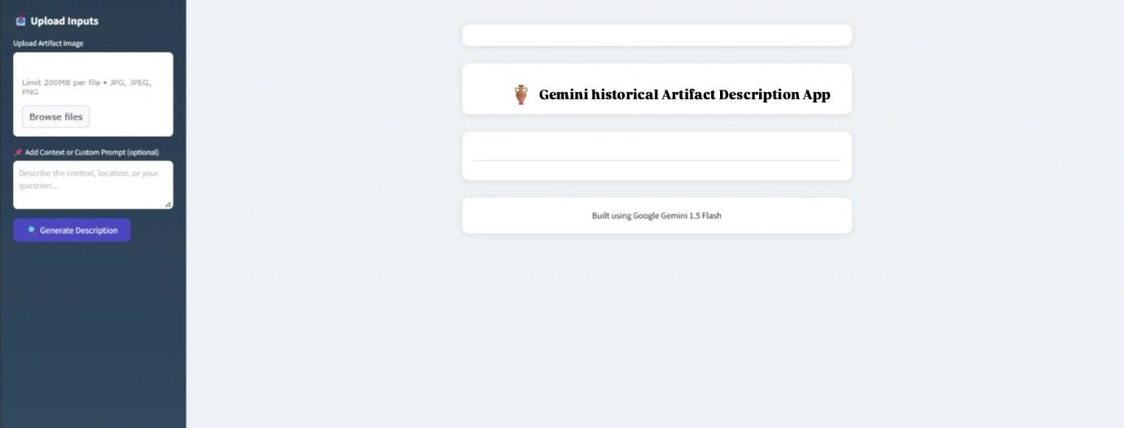
OUTPUT PAGE:

The picture will appear in the main frame once inserted. After the generate description is pressed, the description of the artifact along with the downloadable text file is provided below the image in the main frame.

TESTING:

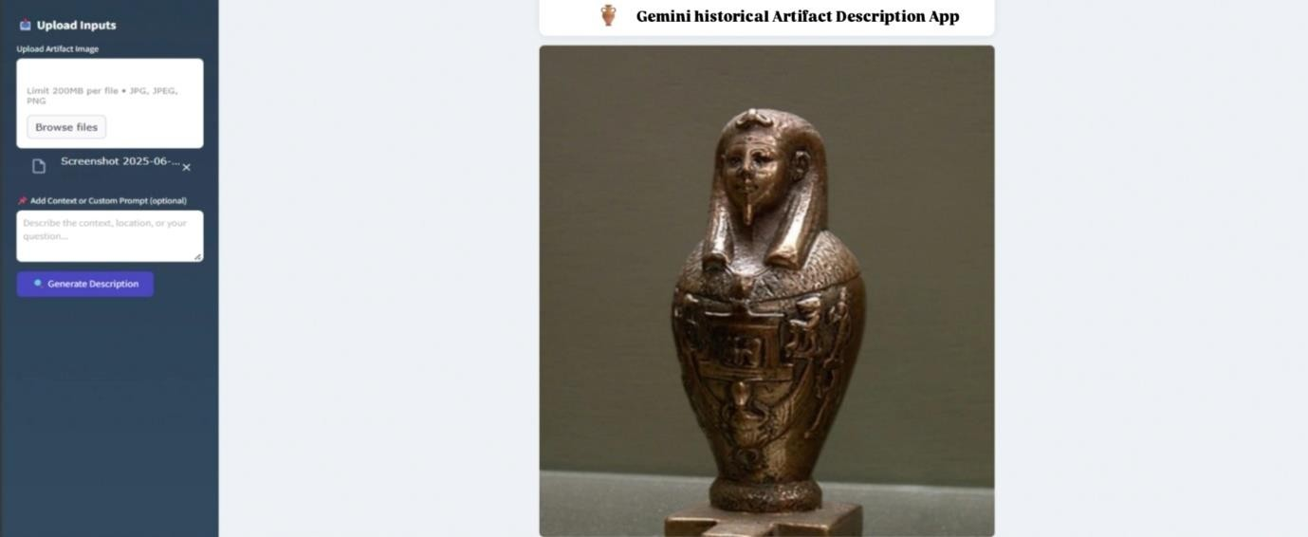
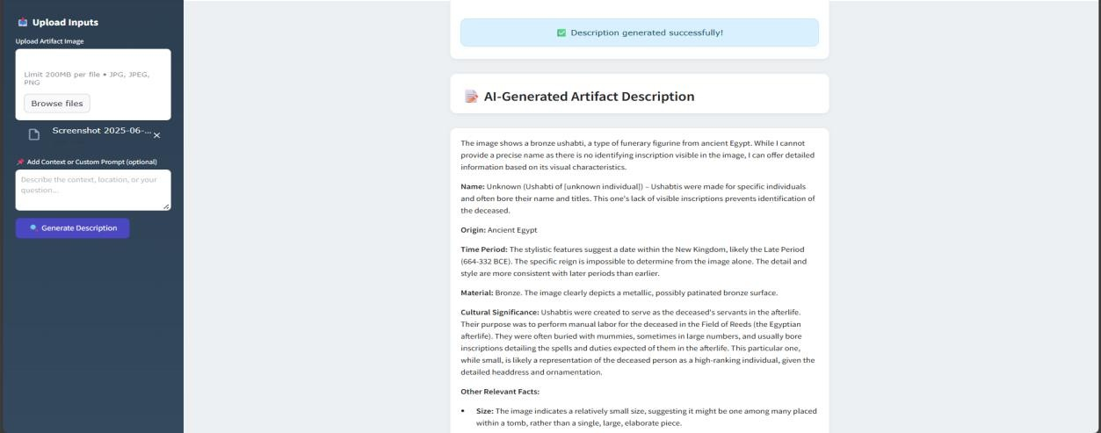
Case1:When only image is uploaded

The description is successfully generated in Case 1.

Case2: When image is uploaded along with prompt.

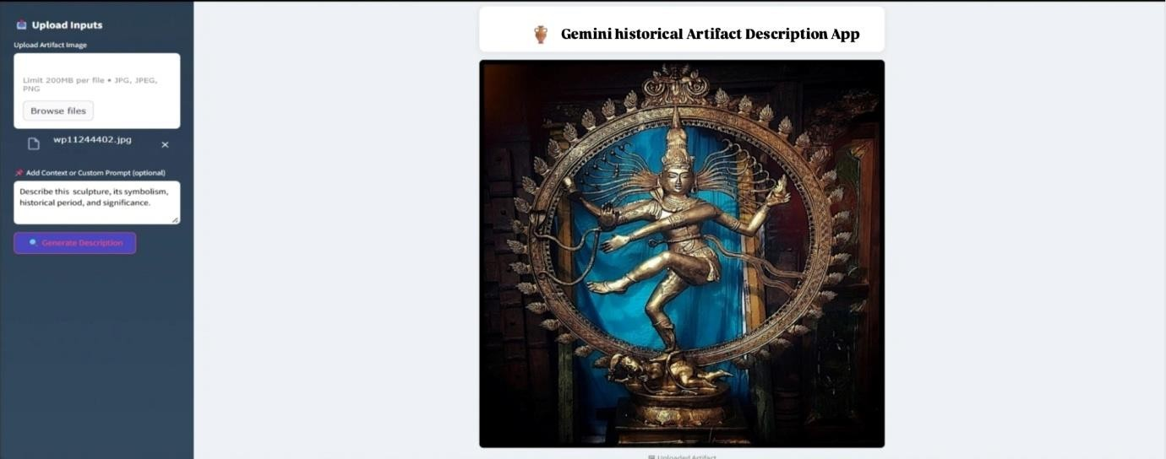
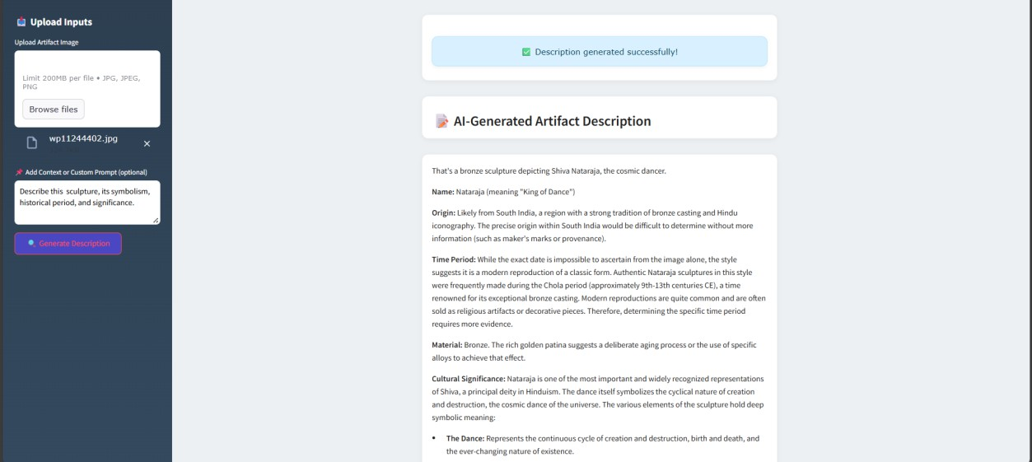
The description is successfully generated in Case 2.

Case3 : When only prompt is given or when the image limit exceeds .

In the above case, the interface produces an error.

ADVANTAGES:
- User-Friendly interface
- Generates the description within seconds

- Useful for people who want to educate themselves on artifacts and don’t have the resources.

NON-ADVANTAGES:
- Dependency on an external API.
- AI might face the problem of hallucination without proper access to current data.

CONCLUSION:
The Gemini Historical Artifact Describer demonstrates how generative AI can support cultural heritage documentation by creating artifact descriptions from images and user prompts. This project shows the potential of AI to help educators and the public in understanding more about historical artifacts at the ease of their fingertips.

